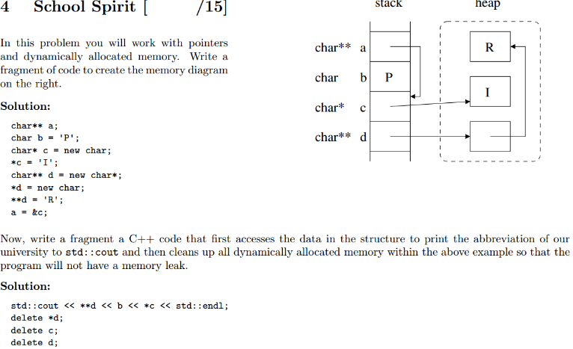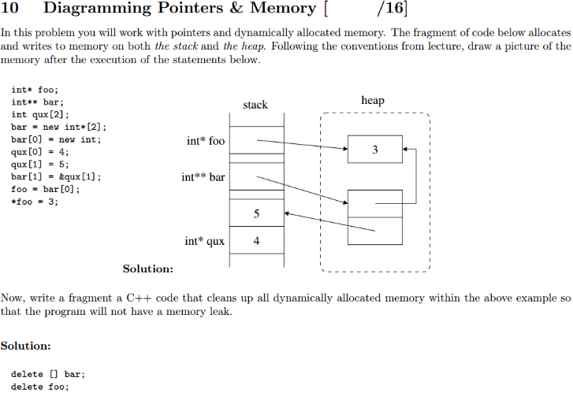
//Example of snowfall class h file  class Snowfall {  public:  // CONSTRUCTOR  Snowfall(const std::string &c, int hours, float inches_per_hour);  // ACCESSORS  const std::string& getCityName() const;  float getTotal() const;  // MODIFIERS  void setSnowInHour(int which_hour, float amount);  private:  // REPRESENTATION  std::string city;  std::vector<float> snow_per_hour;  };  // helper function for sorting  bool by_total_snowfall(const Snowfall &a, const Snowfall &b); | Snowfall::Snowfall(const std::string &c, int hours, float inches_per_hour) {  city = c;  assert (hours >= 1 && inches_per_hour >= 0);  snow_per_hour = std::vector<float>(hours, inches_per_hour);  }  const std::string& Snowfall::getCityName() const {  return city;  }  float Snowfall::getTotal() const {  float total = 0;  for (int i = 0; i < snow_per_hour.size(); i++) { total += snow_per_hour[i]; }  return total;  }  void Snowfall::setSnowInHour(int which_hour, float amount) {  snow_per_hour[which_hour] = amount;  }  bool by_total_snowfall(const Snowfall &a, const Snowfall &b) {  if (a.getTotal() >= b.getTotal()) return true;  else return false;  }
#include <string>, std::string  Using comparison (>, <) operators with strings compares ascii value.  -ascii goes symbols, numbers, capital letters, lower case letters.  -“A” has the lowest ascii value of uppercase letters, ”a” of lowercase  std::string str = “The string.”;  str.insert(3,x); //inserts x at index 3 of string str. | #include <iostream>, std::cout, std::cin  cout << std::endl; // ends line in output stream, clears buffer  //stream manipulators mentioned below are important.  //setprecision requires std::fixed
#include <vector>, std::vector<TYPE> //examples of vectors  vec.push_back(object); //adds object to the end of vec  vector.size() ; //returns size_type (similar to unsigned int) of the length of vector  vector<int> c (1000) //creates a vector of 1000 ints, all unassigned  vector<int> b( c ) //creates a vector that is an exact copy of c, must be similar type  int replace_in_matrix(std::vector<std::vector<int> >& matrix, int old_val, int new_val) {  int rows = matrix.size();  int count = 0;  for (int i = 0; i < rows; i++) {  int cols = matrix[0].size();  for (int j = 0; j < cols; j++) {  if (matrix[i][j] == old_val) {  matrix[i][j] = new_val;  count++;  }  }  }  return count;  } | Don’t forget ++I, I++, and i- -
  Operator | Example | Equivalent expression
  += | index += 2 | index = index + 2
  -= | *(pointer++) -= 1 | *pointer = *(pointer++) - 1
  *= | bonus *= increase | bonus = bonus * increase
  /= | time /= hours | time = time / hours
  %= | allowance %= 1000 | allowance = allowance % 1000
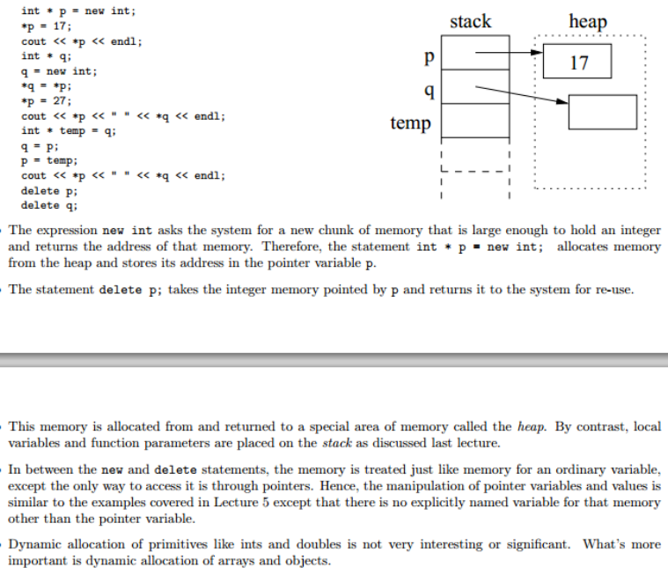 | int main() { //this code parses text, counts words/letters per sentence  std::ifstream istr("little_engine_that_could.txt");  std::string word;  int num_chars = 0;  int num_words = 0;  int num_sentences = 0;  while (istr >> word) {  Solution:  num_words++;  num_chars += word.size();  // when we find the end of a sentence  if (word[word.size()-1] == ‘.’ || word[word.size()-1] == ‘?’ || word[word.size()-1] == ‘!’) {  num_sentences++;  num_chars -= 1;  // print out stats about that sentence  std::cout << "sentence " << std::setw(3) << num_sentences  << " # words: " << std::setw(3) << num_words  << " avg chars/word:" << std::fixed << std::setprecision(1)  << std::setw(5) << num_chars / double(num_words) << std::endl;  // reset the counters  num_chars = 0;  num_words = 0;  }  }  }
Triangle::Triangle(double a, double b, double c) {  a_ = a;  b_ = b;  c_ = c;  }  Triangle::Triangle(const std::vector<double>& vals) {  assert (vals.size() == 3);  a_ = vals[0];  b_ = vals[1];  c_ = vals[2];  }  double Triangle::getPerimeter() const {  return a_ + b_ + c_;  }  3double Triangle::getArea() const {  double s = getPerimeter()/2.0;  return sqrt(s*(s-a_)*(s-b_)*(s-c_));  }  void Triangle::doubleShortestEdge() {  if (a_ <= b_ && a_ <= c_) {  a_ *= 2;  } else if (b_ <= a_ && b_ <= c_) {  b_ *= 2;  } else {  assert (c_ <= a_ && c_ <= b_);  c_ *= 2;  }  } | class Triangle {  public:  // TWO CONSTRUCTORS  Triangle(double a, double b, double c);  Triangle(const std::vector<double>& edges);  // ACCESSOR  double getPerimeter() const;  double getArea() const;  // MODIFIER  void doubleShortestEdge();  private:  // REPRESENTATION  double a_;  double b_;  double c_;  };  TA: Mauricio  Mentors:  Matt S., John Allwein,  Alec, & Fred  SHINIGAMI LOVE APPLES

L-Value/R-Value, sides of equal sign, L-Value finds location in memory.
Add matrix cycling code.
Example of for loop, while loop, if not there
- O(1), a.k.a. CONSTANT: The number of operations is independent of the size of the problem. e.g., compute quadratic root.
- O(log n), a.k.a. LOGARITHMIC. e.g., dictionary lookup, binary search.
- O(n), a.k.a. LINEAR. e.g., sum up a list.
- O(n log n), e.g., sorting.
- O(n2), O(n3), O(nk), a.k.a. POLYNOMIAL. e.g.,
- O(2n), O(kn), a.k.a. EXPONENTIAL. e.g., Fibonacci, playing chess.
Solution: O(n4) We have to search for each of the numbers from 1 ! n2. We look for that number in each of the n2 slots of the matrix. An alternate solution uses a helper vector of n2 bools, and checks o each element as it sweeps through the data ! O(n2). Or if sorting is used, the runtime is O(n2 log n).

